**RO012**

**MHAWB: Evaluating the use of localised Automatic Speech Recognition (ASR) engines for healthcare**

**Research Plan**

a) Rationale

As part of the Smart Nation initiative, a national speech project involving emerging technology has commenced to discover new, innovative applications that are catered to the local context and accent. [1] The Info-communications Media Development Authority (IMDA) has recently developed an ASR engine trained on episodes of the local drama, "Tanglin", and is able to pick up local vocabulary and the local accent much more accurately. Thus, we wanted to use this ASR engine to make processes more efficient in Singapore's context.

With the rise in telemedicine's popularity, we decided to focus on the healthcare sector. ASR engines are also being used in different fields of medicine today. Running ASR applications simultaneously with medical procedures has shown promise [2]. For example, experimental software for dentists allows them to use voice controls while keeping their hands free for dental procedures. Based on this, we found the mental healthcare industry to be an ideal candidate for similar forms of speech recognition-based automation. This also informed our choice of ASR architecture as Kaldi-based implementations have been shown to be stable and suitable for real-time dialogue interpretation [3].

From other research, we found that treating and checking on the patient's mental well-being is often restricted to the therapy sessions alone. This leaves a lot of time outside the therapy sessions to be unaccounted for. As a result, these details in their everyday life are only explained to the psychiatrists long after they have occurred, causing the recount to be more likely to be distorted or lack detail as they implicitly average over many events or days, harming the reliability of the records [4]. In order to tackle this, implementing a logging system along with the ASR will give patients a convenient access point to keep track of their events through speech. By giving psychiatrists access to this logging system, they can also keep tabs on their patients and their accounts of their daily lives to observe if their condition is worsening as well as allowing the data to be more valid. The logging system can also allow patients to see medical notes from their psychiatrists from past sessions in case they need to refer back to them, making the communication between them more efficient.

b) Research Questions, Engineering goals and expected outcome

Our project mainly revolved around the research questions: How can we make Singapore's mental health treatment more efficient and effective through the use of an ASR engine? Having been used in other fields of medicine, would it be possible to include ASR to assist the mental health treatment process? How can we allow monitoring of patients to be more automated so as to help psychiatrists more efficiently keep track of their patients’ progress and lower the chances of any patient's condition worsening without being noticed?

Our engineering goals and expected outcome is to create a fully-functional cross-platform application that can aid in mental health treatment. The application comes with two main features. Firstly, the application will be able to allow psychiatrists to more efficiently transcribe their mental healthcare session and related notes that they wish to add through the use of ASR. This will then be made accessible to the patients, allowing them to refer back to notes on previous sessions should it be required. As psychiatrists notes or therapy sessions may involve more mental health specific terms, the ASR engine also had to be modified to more accurately pick these terms out. Secondly, patients will also be able to keep a record of their everyday emotions through this application. Patients can efficiently use speech to log down their emotion for the day and these logs will also be made available for the psychiatrists to view, allowing them to keep track of the progress the patient is making. The application is also planned to help psychiatrists in keeping track of patients’ progress, thus including an algorithm to detect the presence of depression sentiment. The algorithm will be able to identify if depression sentiments are present in the report logged by patients, thereby alerting the psychiatrist to allow them to monitor the patient more closely should their condition worsen.

c) Procedures, Risk and Safety and Methods for Data Analysis

A dataset was found online from another study about depression sentiments and used for our project. The dataset was split into different groups to be used as both the training dataset - for us to develop an algorithm to detect depression sentiments - and the test dataset, allowing us to assess the accuracy of the algorithm.

The ASR engine was also improved upon by adding mental health related terms. The ASR, the retrained ASR and Mozilla's Deep Speech were then compared against one another through self-recorded audio recordings, with each recording containing mental health related terms, to verify that the retrained ASR was more accurately able to do so.

As the project is purely computational, there was no risk or safety measures required during the project.

b) Bibliography from Literature Review

1. National Speech Corpus. (2018, November 22). Retrieved January 7, 2019, from https://www.imda.gov.sg/NationalSpeechCorpus
2. Johnson, M., Lapkin, S., Long, V., Sanchez, P., Suominen, H., Basilakis, J., & Dawson, L. (2014). A systematic review of speech recognition technology in health care. *BMC medical informatics and decision making*, *14*, 94. doi:10.1186/1472-6947-14-94
3. Plátek, O. (2014). Speech recognition using Kaldi(Doctoral dissertation, Masters thesis, Charles University).
4. Schiepek, G., Aichhorn, W., Gruber, M., Strunk, G., Bachler, E., & Aas, B. (2016). Real-Time Monitoring of Psychotherapeutic Processes: Concept and Compliance. *Frontiers in psychology*, *7*, 604. doi:10.3389/fpsyg.2016.00604

**Abstract**

The area of Automatic Speech Recognition (ASR) has gained popularity in recent times as businesses start to see the viability of this technology to interface with their services. In addition, mental health issues are highly prevalent, and are also suitable for integration of ASR. This project aims to explore the implementation of an ASR engine and evaluate its performance in the specialised medical use case of a Mental Health Chatbot. The Kaldi-based ASR engine created by the Info-Communications Media Development Authority (IMDA) will be used as the basis of this project. The accuracy will be evaluated using self-created audio recordings of sentences containing mental health terms, which is then compared with the unmodified IMDA ASR engine and Mozilla’s tensorflow-based Deep Speech. To enable detection of depressive sentiments in patients, Term frequency-Inverse Document Frequency (TF-IDF) was used in two different approaches, which are Cosine Similarity and Latent Dirichlet Allocation (LDA). The modified IMDA ASR engine implemented in this paper was found to perform significantly better than the unmodified IMDA ASR engine, and slightly better than Mozilla Deep Speech. The Cosine Similarity approach resulted in an error rate of 38%. The LDA approach results in an error rate of 30%, and an average F-measure of 0.75, significantly better than the 0.48 found in existing research. The development of a reliable Mental Health Chatbot is thus found to be largely viable, through the use of modifications and modern NLP methods.

**Report**

**Introduction**

There is a high prevalence of mental health issues in Singapore, with 12% of people experiencing them at least once in their lifetime [1]. For years 2007 to 2010, the Ministry of Health even pushed out the First National Mental Health Policy and Blueprint for Singapore. One its aims was to develop a monitoring and evaluation system [2], which adequately shows the difficulty of keeping track of every patient and assessing their progress. Additionally, as therapy sessions may be scheduled far apart from one another, this causes patients' recounts to more likely be distorted or lack detail as they they tend to implicitly average across multiple events or days and are only reporting it to their psychiatrist long after the incident had occurred, causing the accuracy of the recounts to be affected [3]. This may hinder the mental health treatment process as psychiatrists inaccurately assess the progress of the patients. Thus, through the use of ASR, a convenient access point for patients to record their emotions or events will be provided, alleviating the problem.

There was also a need to develop an evaluation system as mentioned earlier, freeing up psychiatrists, while minimising the risk of having a patient's condition worsen without the psychiatrists noticing. Thus, an algorithm was developed to detect depression sentiments to help in this evaluation process.

As therapy session are also conducted in speech, ASR engines will also be able to more conveniently transcribe therapy sessions to text to be stored and archived for future reference for both the patient and the psychiatrists. However, such sessions or even records by the patients may contain mental health specific terms, which many ASR engines are not able to recognise. Thus, the ASR had to be modified to more accurately pick up these terms.

Literature Review

Open source ASR engines have taken a leap forward in recent times.. Modern Speech-To-Text (STT) services can achieve word error rates (WER) of ~20%. This is comparable to that of human transcribers, performing better than novice or crowd sourced transcriptions (WER of >30%) while falling short of expert transcribers who have an error rate of as low as 15% [4]. However, as with many other forms of data-trained models, ASR engines can be limited in several ways by the kind of data used during the training process in relation to its use case. This means that the aforementioned performance varies considerably by speaker profile within various speaker populations, to an extent of being unusable for real-world applications [5]. As such, specialised ASRs have to be made with specially gathered training data for non-native speaking populations (generally those outside of western english-speaking countries). Examples of such datasets include Singapore’s National Speech Corpus [6], which contain audio recordings of local english speakers and local phrases that can be used by ASR engines to better recognise the speaker population’s accent and colloquial lexicon. In the case of the National Speech Corpus specifically, names of local schools and locations - for example, Serangoon Junior College or Yio Chu Kang - were purposefully included [6]. Finally, the performance of an ASR is also constrained by an inherent speed-accuracy trade-off, where the amount of processing time used by the ASR will affect its statistical models ability to consider all possible hypotheses [7]. This becomes especially apparent when processing speech in a chatbot scenario, as response time becomes a relevant factor to the user experience.

Research Objectives

Our research objective is to create an application, specifically in the local context, that allows patients to record their emotions or events more regularly through the use of an ASR as well as including an algorithm to detect depression sentiments in these reports. Psychiatrists will then have access to this reports to track the progress of their patients. Should a patient consistently have depression sentiments detected, the psychiatrist will then be alerted. The application also archives transcripts of past sessions for easy retrieval by either the patient or the psychiatrist, which would require the ASR to be improved to more accurately pick up mental health specific terms.

**Methodology**

Architecture/Framework

To satisfactorily fulfill the project goals, a local server implementation of the ASR Engine had to be created, which can easily interface with accompanying applications through an API. While primarily for experimental purposes such as convenience of iteration, the creation of an ASR implementation independent of public web services that is able to be run on private networks was important for the intended use case due to the inherent confidentiality of the data handled. With this in mind, the product is structured as shown in Figure 1, where a modified ASR engine generates a transcript using its speech-to-text function. This transcript is then fed into a TF-IDF system for basic analysis and finally verified by a NegEx algorithm before being presented to the user.

Based on this infrastructure, there are several factors to the project that each requires its own experimentation and modification. We have chosen key processes in the framework to work on which are primarily in the accuracy of the speech-to-text function of the ASR and the National Language Processing component that drives our final chatbot.

Implementation of the ASR Engine

The base ASR Engine was created based on the Kaldi Speech Recognition Toolkit [8]. This specific ASR system was ideal to improve on the gaps identified in the literature review. In conjunction with the National Speech Corpus [6], a suitable speech model for locals could be created with Kaldi’s support for speaker adaptation. Finally the speed of the Kaldi system allows it to be used to track dialogue in real-time [9], which allows it to service the needs of a chatbot.

Originally, the IMDA ASR Engine’s distinguishing feature is its increased sensitivity toward the Singaporean user in two ways. Firstly, having been trained on local accents, it is able to better recognise the phonology of Singaporean English speakers, whom have a distinct manner of speech from areas where most historical ASR Speech Repositories have been created, which are mostly in western countries. The other area of interest of the IMDA ASR is in its specialised lexicon which has been expanded to include the names of local terms like food or street names which are not strictly in English as this will aid our logging function. This allows words such as patient's surnames, their address, their school or other localised words to be picked up more accurately by the ASR and be recorded down. This area of ASR vocabulary is also where we hoped to expand on to include more mental health terms for patient-doctor interactions. Thus we modified the ASR Engine but adding WHO’s Lexicon of psychiatric and mental health terms [10] and having the Engine generate the recognised phoenomes automatically.

Finally, to evaluate the increase in accuracy of the ASR Engine, a test using self-created audio recordings of statements containing a variety of mental health terms (Appendix C). These statements were parsed through the ASR Engines and validated against the transcripts of the actual statements. From this, the word error rate was obtained as well as if the specific keyword was picked up.

We selected 3 ASR systems to compare, the original IMDA ASR Engine as a control, our own modified ASR Engine, and Mozilla’s tensorflow-based Deep Speech implementation as a representative of other commercially available ASR. The results are are shown in Fig 2 and 3. As seen in the graphs in Fig 2 and 3, the modified ASR Engine performed significantly better overall in both tests, particularly in its ability to identify specific medical lingo added to its lexicon. Furthermore, the specific manner of pronouncing these specific terms were taken into account by the localisation of the ASR, making it perform better in picking up complex words said by local speakers, as was the case in our self-created dataset.

Natural Language Processing: TF-IDF

To implement a binary classifier to detect depressive sentiments in the patients' accounts, we tried many different approaches. We used a dataset from another depression sentiment analysis study [11] as our training dataset. The dataset comprises 456 tweets relating to depression as well as an integer score from -1 to 1 attached to each tweet. A score of -1 indicates the presence of a depressive sentiment, 0 indicates a neutral sentiment and 1 indicates a tweet showing support to tackle depression. Sample texts of are indicated in Appendix B.

1. *Term Frequency-Inverse Document Frequency (TF-IDF) and Cosine Similarities*

For the first approach, we used a combination of TF-IDF and cosine similarities. [12] TF refers to how often the term occurs in a document (referring to the tweets) while document frequency (DF) refers to the number of documents containing the term. By taking the IDF, we decrease the importance of common words as they are less relevant to the document. 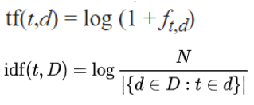

(1)

(2)

The specific TF-IDF formula is shown in equations (1) and (2). *t* refers to each individual word, *d* refers to each individual tweet and *D* refers to the entire dataset of all 456 tweets. Thus, TF-IDF is able to give a vector for each document containing the scores of each word indicating its importance to the document. Since the relevance of a term does not increase linearly with term frequency or document frequency, a logarithmic scale function (sub-linear function) was used for both TF and IDF.

After attaining the TF-IDF vector, cosine similarity was then used to find the similarities between vectors of different documents. Each document is used as a query. The score given to the query will be based on the document which was found to be most similar to it.

As patients' accounts may be rather long, we wanted to investigate if we could make this process more efficient by reducing the number of features - in this case, words - taken into account without compromising the accuracy of the classifier. Thus, we plotted a graph of error rate against the number of features used. From Fig. 4, it can be seen that the error rate stagnates at about 38% when taking into account 15 features. With the longest tweets containing at most 30 words, that is about half of the number of features present. By using 15 features, the time taken can be cut down by about 10% which could amount to a lot for longer documents such as the accounts. However, this error rate is still relatively high. The limitation posed by this TF-IDF approach is that it values terms that are less frequent instead of terms that are actually important and could better signal the presence of depression sentiments. For example, terms such as "depression" were found to be present more in documents with depression sentiment than those without these sentiments, yet due to its high occurrence, the TF-IDF value of the term is extremely low, making it less relevant when being compared to other documents using cosine similarity. Similarly, it was found that terms such as "massive" was found in an equal number of documents with and without depression sentiments, thus not adding much value in predicting if a tweet has depression sentiments. However, the term has a high TF-IDF value due to its low occurrence, causing it to be wrongly regarded as more relevant to detecting depression sentiment. Thus, the approach has the flaw of inaccurately valuing terms that are less useful to identifying depression sentiments more.

*b. Latent Dirichlet Allocation (LDA) via TF-IDF*

After attaining our TF-IDF vectors, LDA was then used to identify the depressive sentiments. [13] In LDA, each document is seen as a mixture of different topics. LDA uses the intuition that each topic is based on a small set of specific words between each document. Thus, by using LDA, we are able to classify these words into separate topics, forming distinct groups of words of different topics.

The dataset was split into five parts to perform 5-fold validation. To do so, one group will be separated each time as the test set while the other four will be used as a training set.

For our training data, LDA was used to identify the different topics. Following which, we found the topic which was most applicable to each document as well as the score, which indicates how suited they are. Each topic was then given a value from -1 to 1 by multiplying the LDA score by the score in the dataset and finding the average. A greater positive indicates that the topic is less likely to contain depression sentiments and vice versa. The test data was then used to validate the accuracy of the classifier. We found the most similar topic to the documents in the test data using LDA and multiplied by the topic's value with the LDA score acquired. This gave us a value from -1 to 1 for all the test documents. An equal error rate graph was then plotted, plotting the false negative rate and the false positive rate to find the intersection, thereby giving an accurate representation of where the threshold should be to classify a text as having depressive sentiments. These are shown in Fig 5.1 to Fig. 5.5. From the graphs in fig 5.1 to fig 5.5, the ideal threshold was about 0, giving an average error rate of about 30%.

A Receiving Operating Characteristic (ROC) curve was also plotted for all 5 tests as can be seen in Fig 6. The area under the ROC curves had an average of 0.73, which is significantly above that of a random classifier with an area under curve of only 0.5. These relatively high values further show that the model's predictions are largely correct, though there is still room for improvement. The F-measure was then calculated when 0 was used as a threshold to identify depression sentiments. The F-measure measures the accuracy of a classifier taking into account both the precision and the recall rate. The average F-measure from all 5 tests was 0.75. In comparison, existing researches [14-15] using LDA for depression sentiment analysis achieve a F-measure of only 0.48. With a significantly higher F-measure than existing literature, it is indicative that our classifier is relatively accurate. However, it is also limited due to the comparatively small dataset that it was trained and tested.

Natural Language Processing: Negation Detection

To complement the TF-IDF sentiment analysis, a negation detection system had to be implemented as a second round of checking for false positive or false negative detection. We selected the NegEx Algorithm implemented used in evaluating negative diagnosis to achieve this. NegEx operates by identifying negative modifiers such as “not” or “never” and assigns flags statements that contains such phrases, allowing the system to potentially invert results where a dependence relation is established.

Figure 7 expounds on the process of NegEx algorithm. This was implemented as a post-process to the transcription and the TF-IDF analysis of sentiment diagnoses, in which the NegEx algorithm searches for pre-identified negation phrases in order to re-evaluate the prescribed diagnosis [16-17]. For the purposes of this project’s proof-of-concept which was a binary positive or negative depressive sentiment, NegEx was implemented to verify the validity of the negativity or positivity of the statement based on whether or not modifiers were taken into account. This would hence result in a lowered overall error rate of diagnosis of prescribed text. Running a java-based adaptation of the original NegEx Algorithm [17] yielded promising results as there was an 77.6% positive predictive value and 75.2% negative predictive values for sentences with identified negation phrases and a 88.9% negative predictive value for sentences that lacked negation phrases.

**Conclusion**

In conclusion, this project shows that currently, the development of a reliable Mental Health Chatbot is viable to an extent. As shown, current ASR technology can be modified to accommodate the vocabulary of varied specialised, in this case the Mental Health Industry. Our project demonstrates that running a modified ASR Engine is a viable way of overcoming the inability of traditional ASR systems to process complex words, especially those spoken by individuals in a Singapore context. Furthermore, the use of modern NLP methods can be used in conjunction with a high-accuracy ASR Engine-generated transcript can give significant insight to ease the monitoring and evaluation of mental health patients. Specifically, the use of TF-IDF trained on user-generated content that was pre-evaluated from emotional sentiments in conjunction with a negation detection system that reduces the occurrence of false positive or false negative diagnoses, can also automatically give valuable insights to medical professionals when looking through lengthy transcripts and focus in on insightful parts of anecdotal evidence gathered from patients during mental health sessions. As such, it can be seen that the implementation of ASR and NLP for mental healthcare value-adds to health care processes and can be relied on to increase the efficiency and productivity of mental healthcare workers.

References:

1. Siow, A., Abdin, E., Vaingankar, J., Heng, D., Sherbourne, C., Yap, M., Subramaniam, M. (2012). A population-based survey of mental disorders in Singapore. *Ann Acad Med Singapore,* *41*(2), 49-66.
2. Chong, S. A. (2007). Mental health in Singapore: a quiet revolution?. *Annals-Academy of Medicine Singapore*, *36*(10), 795.
3. Schiepek, G., Aichhorn, W., Gruber, M., Strunk, G., Bachler, E., & Aas, B. (2016). Real-Time Monitoring of Psychotherapeutic Processes: Concept and Compliance. *Frontiers in psychology*, *7*, 604.
4. Zechner, K. (2009). What did they actually say? Agreement and disagreement among transcribers of non-native spontaneous speech responses in an English proficiency test. In *International Workshop on Speech and Language Technology in Education*.
5. Potamianos, A., Bouselmi, G., Dimitriadis, D., Fohr, D., Gemello, R., Illina, I., ... & Ramirez, J. (2006, May). Towards speaker and environmental robustness in ASR: the hiwire project. In *SRIV'06 ITRW on Speech Recognition and Intrinsic Variation*.
6. National Speech Corpus. (2018, November 22). Retrieved January 7, 2019, from https://www.imda.gov.sg/NationalSpeechCorpus
7. Ivanov, A. V., Lange, P. L., Suendermann-Oeft, D., Ramanarayanan, V., Qian, Y., Yu, Z., & Tao, J. (2016). Speed vs. accuracy: Designing an optimal asr system for spontaneous non-native speech in a real-time application. *Proc. of the IWSDS, Saariselk, Finland*.
8. Povey, D., Ghoshal, A., Boulianne, G., Burget, L., Glembek, O., Goel, N., ... & Silovsky, J. (2011). The Kaldi speech recognition toolkit. In *IEEE 2011 workshop on automatic speech recognition and understanding* (No. EPFL-CONF-192584). IEEE Signal Processing Society.
9. Plátek, O. (2014). Speech recognition using Kaldi(Doctoral dissertation, Masters thesis, Charles University).
10. World Health Organization. (‎1994)‎. Lexicon of psychiatric and mental health terms. 2nd ed.<http://www.who.int/iris/handle/10665/39342>
11. Ramji, A. (2017, June 26). *Tweetdata* [txt]. Ashwanth Ramji.
12. Huang, A. (2008, April). Similarity measures for text document clustering. In *Proceedings of the sixth new zealand computer science research student conference (NZCSRSC2008), Christchurch, New Zealand* (pp. 49-56).
13. Li, S. (2018, May 31). Topic Modeling and Latent Dirichlet Allocation (LDA) in Python. Retrieved December 22, 2018, from https://towardsdatascience.com/topic-modeling-and-latent-dirichlet-allocation-in-python-9bf156893c24
14. Resnik, P., Garron, A., & Resnik, R. (2013). Using topic modeling to improve prediction of neuroticism and depression in college students. In *Proceedings of the 2013 conference on empirical methods in natural language processing* (pp. 1348-1353).
15. Resnik, P., Armstrong, W., Claudino, L., Nguyen, T., Nguyen, V. A., & Boyd-Graber, J. (2015). Beyond LDA: exploring supervised topic modeling for depression-related language in Twitter. In *Proceedings of the 2nd Workshop on Computational Linguistics and Clinical Psychology: From Linguistic Signal to Clinical Reality* (pp. 99-107).
16. Manimaran, J., & Velmurugan, T. (2017). Evaluation of lexicon- and syntax-based negation detection algorithms using clinical text data. *Bio-Algorithms and Med-Systems,* *13*(4). doi:10.1515/bams-2017-0016
17. Chapman, W. W., Bridewell, W., Hanbury, P., Cooper, G. F., & Buchanan, B. G. (2001). A Simple Algorithm for Identifying Negated Findings and Diseases in Discharge Summaries. *Journal of Biomedical Informatics,* *34*(5), 301-310. doi:10.1006/jbin.2001.1029

**Appendix A**

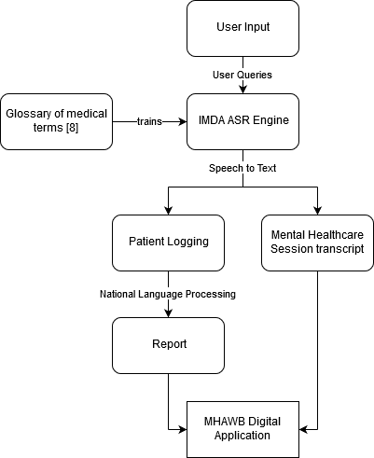

Figure 1. Application Architecture

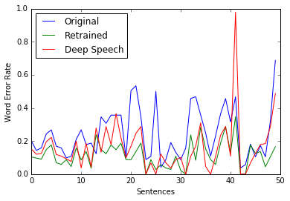

Figure 2: Graph of word error rate against number of sentences used in ASR.

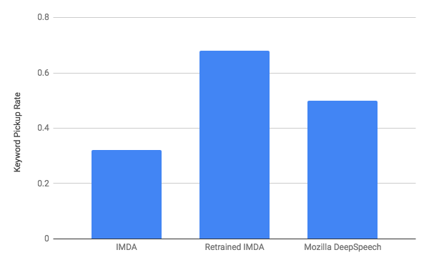

Figure 3. Percentage of keywords successfully identified

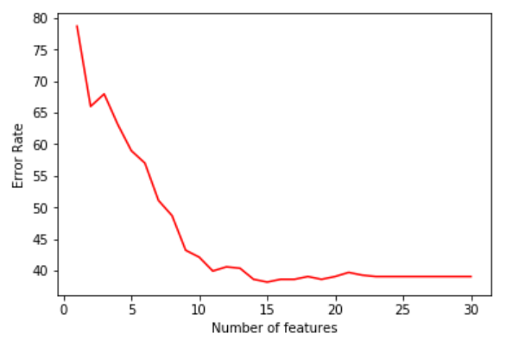

Fig 4. Graph showing error rate against number of features that was taken into account

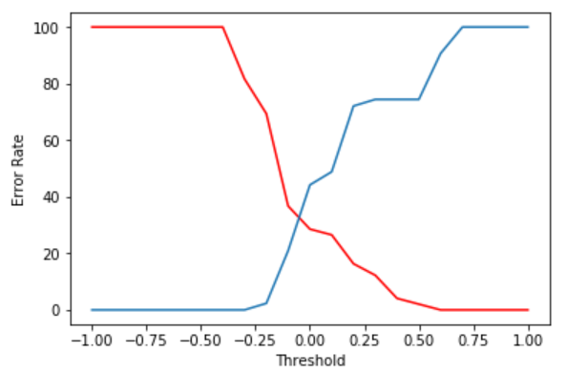



Fig 5.1. Graph showing error rates against threshold for first test dataset

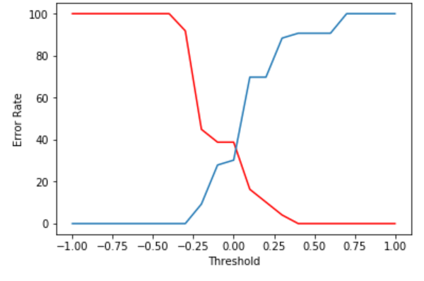



Fig 5.2. Graph showing error rate against threshold for second test dataset

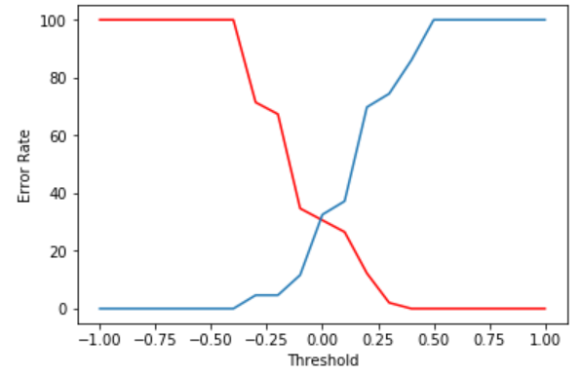



Fig 5.3. Graph showing error rate against threshold for third test dataset

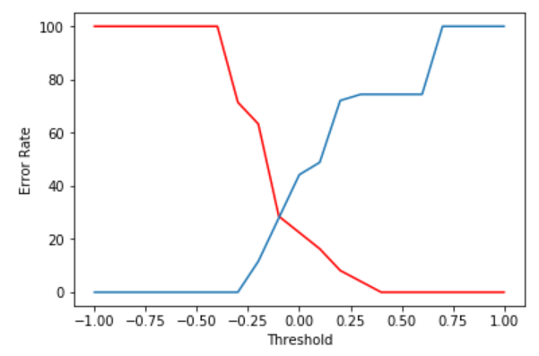



Fig 5.4. Graph showing error rate against threshold for fourth test dataset

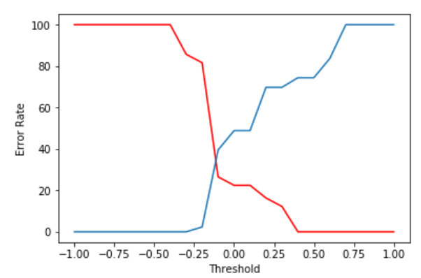



Fig 5.5. Graph showing error rate against threshold for fifth test dataset

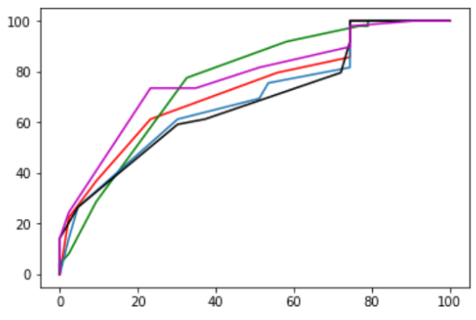







Fig 6. Receiving Operating Characteristic (ROC) Curve for all 5 tests

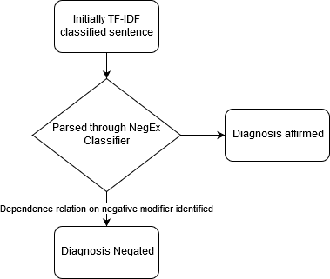

Figure 7. NegEx process

**Appendix B: Sample of depression sentiment analysis dataset**

**Score:** -1

**Tweet:** "y'all i was having an anxiety attack yesterday thinking i wouldn't be able to go to school tomorrow bc i had no gas and couldn't pay tuition"

**Score:** 0

**Tweet:** "Anxiety can affect your ability to concentrate, sleep & perform daily tasks. For more info, visit https:\/\/t.co\/eS4wtJ5n2D"

**Score:** 1

**Tweet:** "Men, seeking help for depression, anxiety or any mental health issue is an act of self - love that you deserve."

**Appendix C: Test Sentences**

1. he was using dream abreaction to treat a patient  
2. Agoraphobia is a type of anxiety disorder  
3. I think I might have Benzodiazepine withdrawal symptoms  
4. Binswanger's disease is a form of small vessel vascular dementia  
5. violent imagery and musical dissonance induce a state of catatonia  
6. People who confabulate present incorrect memories and are generally very confident about their recollections  
7. So that transforms your dipsomania into an actual weekend event.  
8. at least 2 years of dysthymia lead to recurring major depression  
9. Based on this assumption she recommends therapy for egodystonic people.  
10. The patient is suffering from endogenous depression  
11. He shows florid symptoms of psychiatric disorder  
12. What are the symptoms of dissociative fugue?  
13. Gerstmann syndrome is a neuropsychiatric disorder  
14. Granulovacuolar degeneration involves the accumulation of large, double membrane-bound bodies  
15. I just had a histrionic outburst  
16. Hyperkinetic disorder is also known as ADHD  
17. drugs may cause side effects which can lead to iatrogenic disease  
18. Infarction of the brain is very dangerous  
19. Jargon aphasia makes an individual’s speech incomprehensible  
20. Juvenile tabes is a rare disorder  
21. Her lawyer said she suffered from kleptomania.  
22. Kuru is a very rare, incurable neurodegenerative disorder  
23. he may prescribe a laxative to ease the congestion  
24. she spoke softly, lisping slightly  
25. the doctor said my son was a malingerer  
26. the migraines might return  
27. People with narcolepsy often find it difficult to stay awake for long periods of time  
28. this is an example of neurosis  
29. oligophrenia is an old word for mental retardation  
30. Symptoms of the disorder include a strong desire to use opioids  
31. I commited parasuicide  
32. He is known to be a peregrinating patient  
33. A querulant is a person who obsessively feels wronged  
34. Reserpine might lead to the precipitation of a depressive state  
35. This is an infection caused by the rubella virus  
36. She was subsequently diagnosed with paranoid schizophrenia  
37. It is more beneficial if the steroid can be given twice in a 48 hour period  
38. People who have trichotillomania have an irresistible urge to pull out their hair  
39. That will lead to an incidentally irreversible thiamine deficiency  
40. specialists in victimology will consider how best to help the victims of crime recover  
41. Internet sites dedicated to the act of voyeurism  
42. Wernicke's aphasia causes difficulty speaking in coherent sentences  
43. Inversion of the circadian rhythm causes sleep disorder  
44. somewhere a patient shouted in delirium  
45. People who have hypersomnia can fall asleep at any time  
46. Nosophobia is the irrational fear of contracting a disease  
47. he had a nervous tic around his left eye  
48. many foreigners undergo acculturation and modify their lifestyles  
49. His message was written in a deliberately elliptical style.  
50. he was treated for melancholia and insomnia